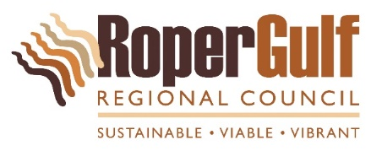

**Installation of Playground Soft Fall Rubber**

**Scope of work**

**Barunga Community**

1. **Proposed Construct Works**
   1. Supply and install Soft Fall rubber 14.8m (Length) x 12.5m (Width) to Playground area
   2. Use existing sand and compact to make sub base for rubber installation
   3. Install shock pads around equipment and top coat to Australian Standards
2. **Certifications**
   1. Critical Fall of height Drop test certification to Australian Standards
3. **Work Health and Safety**
   1. Work site must be security fenced and strict entry for authorized personal only during construction period.
4. **Waste Management Facility usage in Barunga**
   1. No debris or waste from the works are to be dumped at the Barunga Waste Management facility under in any circumstances. It is the responsibility of the Contractor to remove all waste materials from the site prior to handover.

Contractor to specify proposed treatment of any waste and debris from the site.

1. **Project Completion and handover**
   1. The site must be clean and tidy prior to final inspection.
   2. All certifications must be handed over to Project Coordinator prior to the final payment.